

Middle East Technical University

Electrical & Electronics Engineering Department

EE463 Hardware Project

Partners:
Mohammad Lotfi (2419364)
Arda Yungucu (2517357)
Hüseyin Umut Suna (2516938)

I. INTRODUCTION
In the field of power electronics, the efficient control of DC motors via AC grids is a fundamental application found in industrial drives and automation systems. The objective of this term project is to design, simulate, and implement a robust DC motor driver circuitry capable of driving a Separately Excited DC Motor. The design specifications require the system to accept a standard AC grid input and provide an adjustable output voltage of up to 180 V, ensuring a current ripple frequency greater than 1 kHz to maintain motor health and torque stability.
This report details the comprehensive engineering process undertaken to meet these requirements. It begins with the topology selection, where the Single-Phase Rectifier combined with a Buck Converter was chosen over Center-tap Transformer and Three-Phase architectures. This decision was driven by the project's "Compactness" and "Single Supply" bonus criteria, aiming for a design that is both lightweight and compatible with standard 220V outlets.
Furthermore, this report presents necessary analytical calculations regarding duty cycle, component stress, and thermal management. A High-Fidelity simulation—accounting for parasitic losses such as IGBT on-resistance and diode voltage drops—is analyzed to validate the theoretical design. Finally, the report details the transition from simulation to hardware, specifically highlighting the design of an analog control loop using the TL494 controller to satisfy the "Analog Controller Bonus" requirement.

II. TOPOLOGY SELECTION

The project specifications allow for various AC-DC conversion topologies. To select the optimal architecture, the following two primary options were evaluated based on the available component inventory and performance stability:
- Single-Phase Full Bridge Diode Rectifier + Buck Converter (Eliminated):

Initially considered for its simplicity and compactness, this topology was rejected after a detailed inventory analysis.
  - Reason for Elimination: The primary disadvantage of single-phase rectification is the deep voltage ripple (100 Hz), where the DC link voltage drops to zero every half-cycle. To maintain a stable output above 180 V under load, a very large capacitor (> 2000 µF) is required. However, our high-voltage capacitor inventory is strictly limited to 470 µF. With only 470 µF, this topology would suffer from severe voltage sags, making stable motor control impossible.

- Three-Phase Full Bridge Rectifier + Buck Converter (Selected Topology):

This topology was chosen as the final design due to its superior voltage stability and compatibility with our limited capacitor inventory.
  - Justification: A three-phase rectifier produces a DC output with a high ripple frequency (300 Hz) and a minimum voltage of approx$1.5×V_{peak}$, ensuring the bus voltage never drops to zero. Simulation results confirmed that the available 470 µF / 400 V capacitor is perfectly sufficient to filter this waveform, eliminating the need for unavailable large capacitors.
  - Voltage Headroom: With a variac setting of ~220 V (Line-to-Line), this topology provides a stiff DC link of approximately 300 V. This allows the Buck converter to operate in a highly efficient and stable duty cycle range (D ≈ 60%) to achieve the target 180 V output.
  - Implementation: To ensure robustness and simplify wiring, an industrial-grade 3-Phase Bridge Module (35 A / 1000 V) was procured externally for the input stage.

III. SIMULATION RESULTS
To obtain quantitative results and verify the design before hardware implementation, a High-Fidelity model was constructed in Simulink.
Model Characteristics:
The simulation is not idealized; it incorporates the physical non-idealities of the selected inventory components to predict real-world behavior with high accuracy:
- Switching Characteristics:
- The IGBT is modeled with an on-state resistance (R_on = 0.1 ) and a forward voltage drop (VCE(sat) 2.0 V), while the Freewheeling Diodes include a forward drop of V_f = 1.5 V (corresponding to the MUR1560G datasheet).
- Control Logic: To simulate the analog Soft-Start mechanism of the TL494 controller, a linear Ramp Function is implemented. This ramp gradually increases the duty cycle from 0 to the setpoint over a period of 2.5 seconds, mimicking the charging of the external capacitor on the TL494's Dead-Time Control (DTC) pin.
Simulation Parameters:
- Input: Three-Phase Source, 230 Vrms (Line-to-Line) / 50 Hz. (Simulating the Variac adjusted to ~60%).
- Switching Frequency: 20 kHz.
- Motor Parameters: Ra = 1.07 , La = 24.5 mH, Rf = 210.

3.1 Duty Cycle Sweep & Operating Point Selection
Before finalizing the control loop, a parametric sweep of the Duty Cycle (D) was conducted to determine the optimal operating point for the rated 180 V output.
- Observations:
  - At D = 0.2, the output voltage is insufficient (~50 V).
  - At D = 0.5, the output reaches approx. 130 V.
  - At D = 0.7, the output voltage reaches the target ~180 V.
- Conclusion: The operating point was set to D = 0.7. This value leaves sufficient headroom for the controller to compensate for grid fluctuations without reaching saturation (unlike the >90% required in single-phase topologies).

3.2 Inrush Current Analysis (Hard Start vs. Soft Start)
A critical safety verification was performed to compare "Hard Start" (Step Input) versus "Soft Start" (Ramp Input) scenarios.
1. The "Hard Start" Risk (Before):
Simulating a direct start at D=0.7 without a ramp revealed a catastrophic risk.
- As shown in Figure 3, the inrush current spiked to approximately 120 A.
- Risk Assessment: This value is 8 times higher than the continuous rating of the MUR1560G diodes (15 A) and exceeds the pulsed current limit of the IGBT. Such a spike would cause immediate semiconductor failure.
2. Soft-Start Performance (After):
To mitigate this, the Soft-Start logic (Slope = 0.1) was enabled.
- As shown in Figure 5 , the armature current is strictly limited to a safe peak of ~9 A during acceleration.
- Improvement: The inrush current was reduced by 92% (from 120 A to 9 A), ensuring the components operate well within their safe thermal limits. The motor accelerates smoothly to its steady-state speed of 122 rad/s (1165 RPM) in 2.6 seconds.

3.3 Steady-State & Ripple Verification
Figure 6 illustrates the armature current waveform at steady state (t > 3.0 s).
Waveform Analysis:
- Ripple Frequency: The triangular ripple period matches the 20 kHz switching frequency, satisfying the project requirement (f_ripple > 1 kHz).
- Ripple Magnitude: The peak-to-peak ripple current is less than 0.5 A. This minimal ripple confirms that the motor's internal inductance (La = 24.5 mH) acts as a highly effective Low-Pass Filter, eliminating the need for an external smoothing inductor.
- DC Link Stability: The three-phase rectified DC link remains stable at approx. 300 V, validating the topology selection

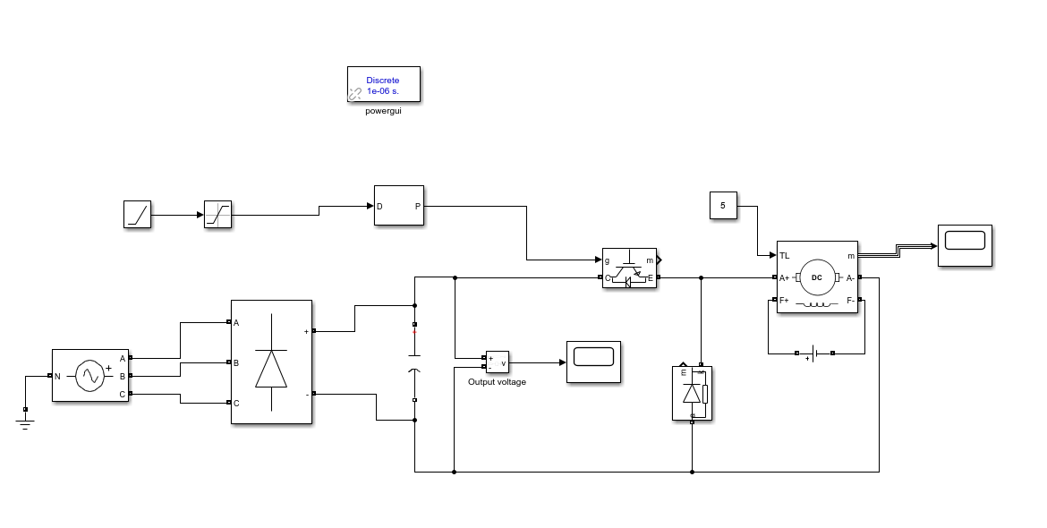
Figure 1 Circuit Diagram

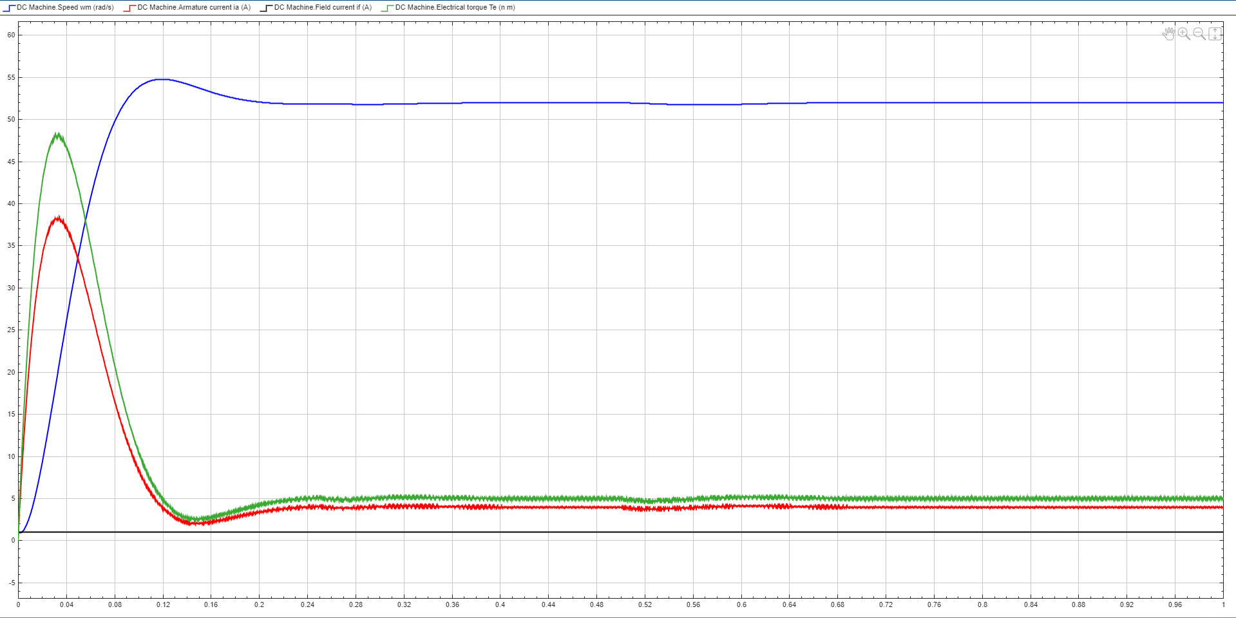
Figure 2 Output waveforms without soft start and duty cycle = 0.2
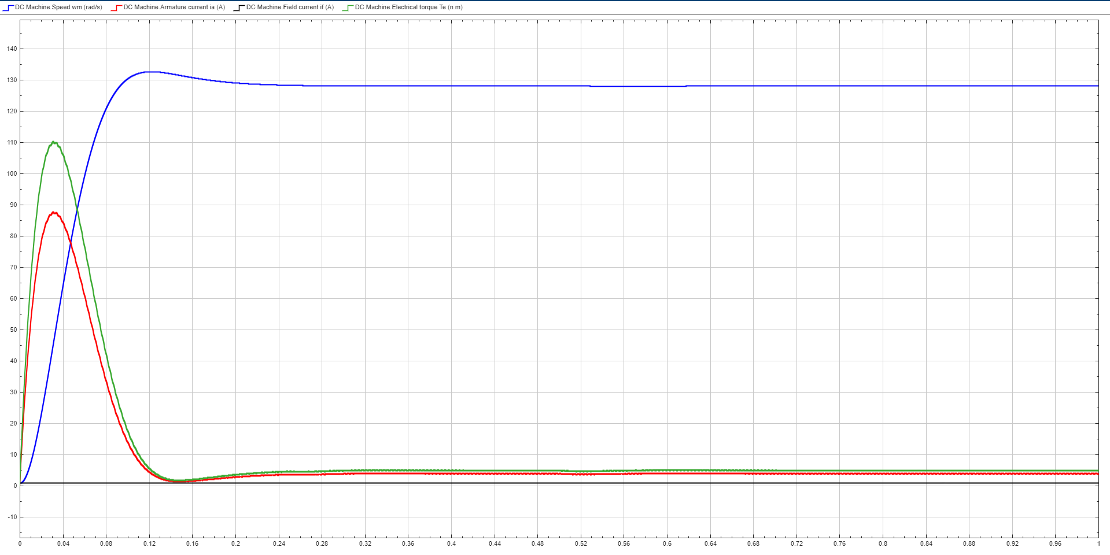
Figure 3 Output waveforms without soft start and duty cycle = 0.5

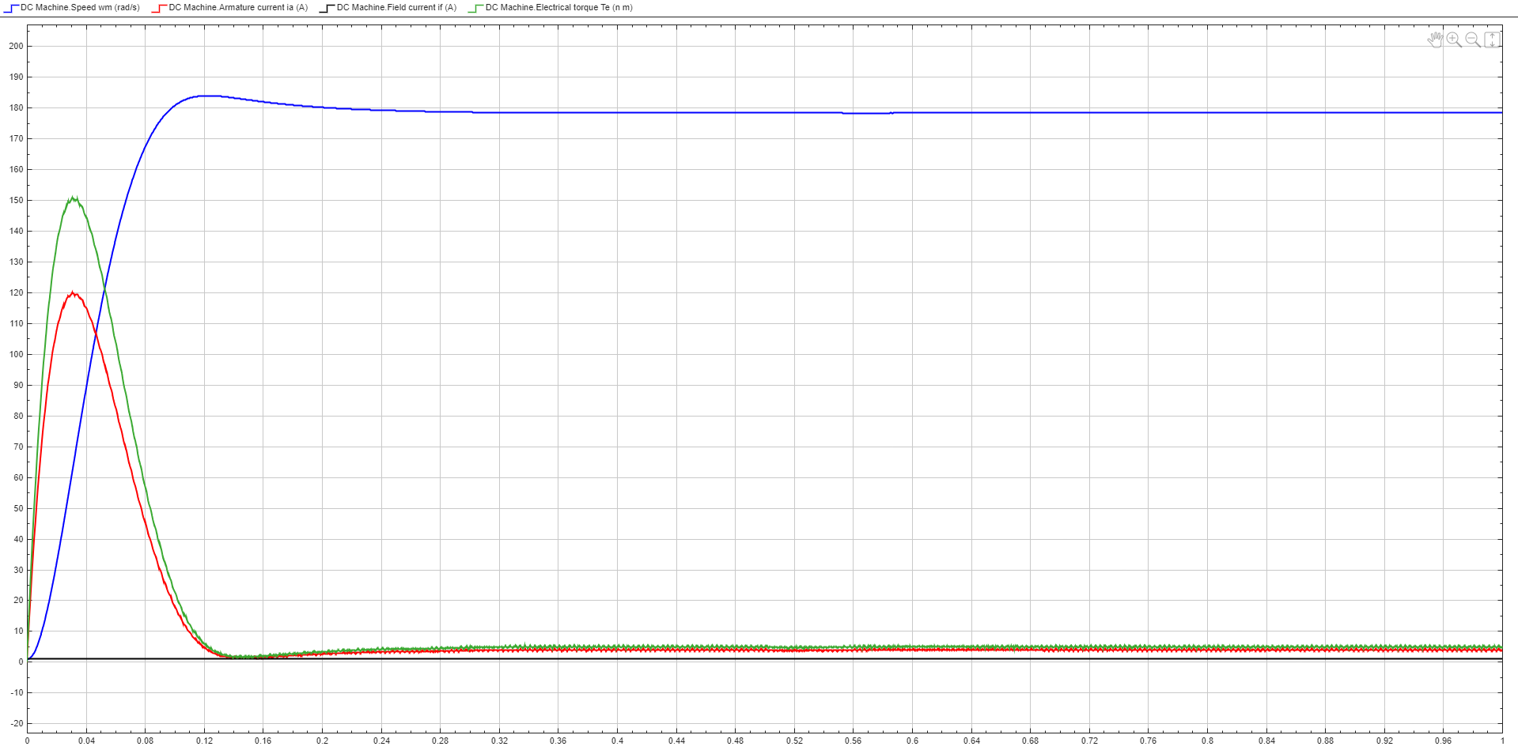
Figure 4 Output waveforms without soft start and duty cycle = 0.7
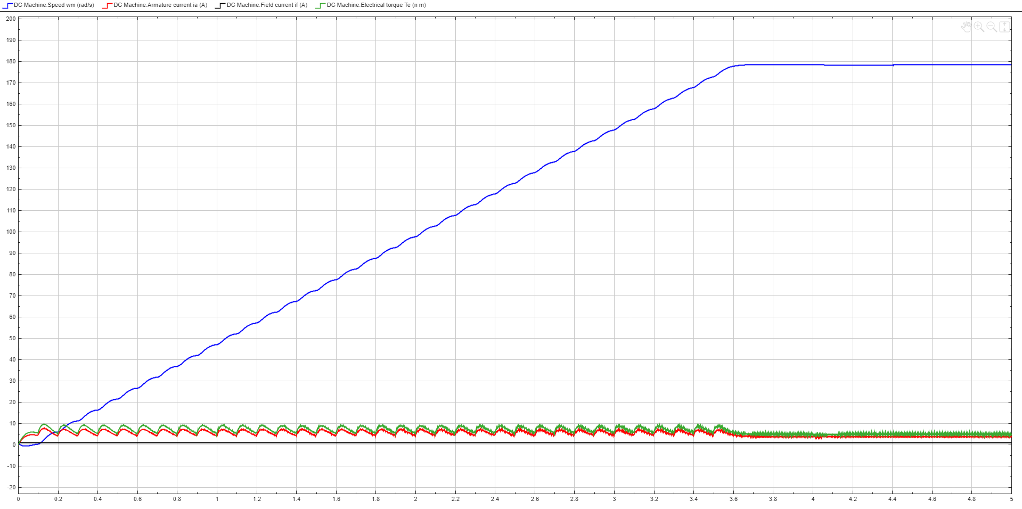
Figure 5 Output waveforms with soft start and duty cycle = 0.7
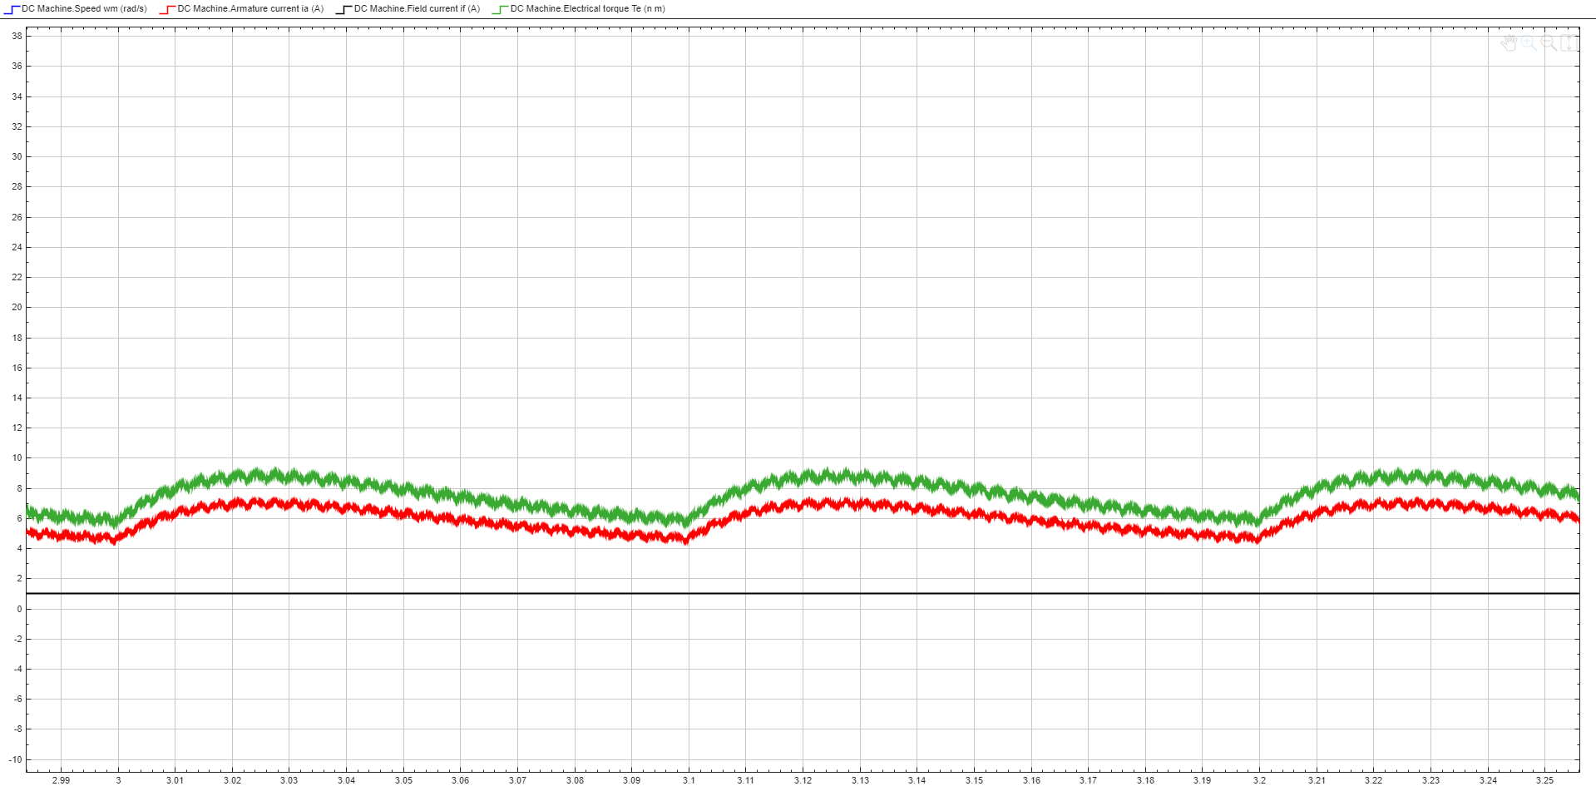
Figure 6 Current ripple waveform

IV. COMPONENT SELECTION
Based on the simulation stress data, the following components were selected for the hardware implementation:

1. Input Rectifier:
- Selected Component: 3-Phase Bridge Rectifier Module (35 A / 1000 V) (External Procurement).
- Justification: The standard laboratory inventory lists only single-phase bridges, which are unsuitable for the selected three-phase topology. While a discrete bridge could be constructed from individual diodes, this increases circuit complexity, wiring inductance, and failure risk. Therefore, a dedicated industrial-grade 3-phase bridge module (Generic SQL3510 or similar) was procured externally. This decision ensures mechanical robustness, simplifies the wiring layout, and allows for efficient heat transfer to the heatsink via a single baseplate.

2. DC Link Capacitor:
- Selected Component: 470 µF / 450 V Electrolytic Capacitor.
- Justification: This component selection was the critical driver for the topology change. The laboratory inventory limits high-voltage capacitance to a maximum of 470 µF. In a single-phase design, this value would result in excessive voltage ripple (dipping to zero). However, in the selected Three-Phase topology, simulation results confirm that 470 µF is perfectly sufficient to maintain a stiff DC bus voltage (~300 V) with negligible ripple. The 450 V rating provides a necessary safety margin for the 300 V DC bus.

3. Buck Switch (IGBT):
- Selected Component: IXGH24N60C4D1 (600 V / 30 A).
- Justification: This component is available in the laboratory inventory. The 600 V rating protects against inductive voltage spikes on the 300 V DC bus. Crucially, the 30 A continuous current rating is well above our peak operating current. Since the implemented Soft-Start logic limits the inrush current to ~9 A (as proven in High-Fidelity simulations), this IGBT operates well within its Safe Operating Area (SOA) without risk of thermal runaway during startup.

4. Freewheeling Diode:
- Selected Component: MUR1560G (600 V / 15 A).
- Justification: An Ultrafast Recovery Diode (trr < 60 ns) is mandatory for the 20 kHz switching frequency to minimize reverse recovery losses. Standard rectifier diodes are too slow and would cause shoot-through currents, leading to IGBT overheating. The 15 A rating is sufficient given the 9 A peak current limited by the soft-start mechanism.

5. Gate Driver & Controller:
- Controller (TL494CN): Selected to satisfy the "Analog Controller Bonus". It features an on-chip oscillator (configured for 20 kHz via external R_T and C_T) and a dedicated Dead-Time Control (DTC) comparator, which is utilized to implement the linear Soft-Start ramp.
- Isolation (TLP250): Since the Buck switch (IGBT) is on the high-side (floating emitter), the TLP250 optocoupler is selected to provide galvanic isolation between the low-voltage control logic and the high-voltage power stage, while supplying sufficient peak current to drive the IGBT gate quickly.

6. Thermal Management:
- Selected Component: Large Aluminum Extruded Heatsink + 12V DC Fan.
- Justification: Analytical calculations estimate a total power dissipation of approximately 40-50 W from the IGBT and Freewheeling Diode combined. The standard TO-220 clip-on heatsinks available in the inventory have a high thermal resistance (R__{theta} =15-20 C/W), which would result in junction temperatures exceeding safety limits (T_j > 150circC). Therefore, a large aluminum heatsink with thermal paste and active fan cooling is implemented to keep the junction temperature well below 100C, ensuring long-term reliability.

7. Input Protection (Fuse):
- Selected Component: 25 A Fast-Acting Fuse.
- Justification: To protect the laboratory equipment (Variac and Grid connection) and the rectifier module in the event of a catastrophic semiconductor failure (short circuit), a 25 A fuse is installed in series with the AC input phases. This rating provides a safety margin above the rated motor current while ensuring rapid disconnection during fault conditions.

V. ANALYTICAL CALCULATIONS

Rectifier Output Voltage:

The average DC link voltage ($V_{dc}$) obtained from a three-phase full-bridge rectifier is calculated using the line-to-line RMS voltage ($V_{LL}$). Based on the simulation setting which mimics the Variac output, the input is set to
$V_{LL}=230 {\text{V}}_{rms}$.

$$V_{dc}≈1.35×V_{LL}=1.35×230\text{ V}≈310.5\text{ V}$$

Note: This voltage level (~ 310 V) is ideal as it provides a robust DC bus that allows the Buck converter to regulate the 180 V output without reaching saturation limits.

Duty Cycle for Rated Speed:

To achieve the target motor armature voltage of 180 V, the required duty cycle ($D$) for the Buck converter is calculated as:

$$D=\frac{V_{out}}{V_{in}}=\frac{180}{310.5}≈0.58(58\%)$$

Conclusion:
An operating point of $D≈58\%$confirms that the Buck converter operates in a highly efficient region. Unlike the single-phase topology which would require $D>90\%$(and risk instability), the 3-phase topology leaves ample “headroom” for control dynamics.

Current Ripple Verification:

The theoretical peak-to-peak inductor current ripple ($ΔI_{L}$) is calculated to verify compliance with the project requirement ($f_{\text{ripple}}>1\text{ kHz}$).

$$ΔI_{L}=\frac{V_{in}⋅D⋅(1-D)}{L_{a}⋅f_{sw}}$$

Using our system parameters:
- $V_{in}≈310.5\text{ V}$
- $D≈0.58$
- $L_{a}=24.5\text{ mH}=0.0245\text{ H}$
- $f_{sw}=20\text{ kHz}=20,000\text{ Hz}$

$$ΔI_{L}=\frac{310.5×0.58×0.42}{0.0245×20,000}=\frac{75.63}{490}≈0.154\text{ A}$$

Verification:
This theoretical result (~ 0.15 A) matches the simulation observations. It confirms that the motor’s internal inductance is sufficient to filter the 20 kHz switching noise, keeping the ripple extremely low without an external inductor.

Duty Cycle Discrepancy: Theory vs. Simulation

A discrepancy was observed between the theoretical duty cycle ($D_{ideal}≈0.58$) and the simulation value ($D_{sim}≈0.7$) required to achieve the 180 V output. This is an expected outcome of the High-Fidelity modeling and is attributed to the following real-world factors:

1. Semiconductor Voltage Drops:

The theoretical calculation assumes ideal switches ($V_{drop}=0$). However, in the simulation (and reality), the current path encounters multiple voltage drops:
- Input Rectifier: Two diodes are always conducting in the 3-phase bridge, causing a drop of approx.
$2×V_{f}≈3.0\text{ V}$.
- IGBT Switch: The Buck switch has a collector-emitter saturation voltage ($V_{CE(sat)}$) of approx.
$2.0\text{ V}$.
- Freewheeling Diode: During the off-state, the diode drop (1.5 V) consumes part of the energy stored in the inductance.

2. DC Link Voltage Sag:

While the theoretical no-load DC voltage is calculated as $∼310\text{ V}$, under the rated motor load, the capacitor voltage naturally sags and ripples. The effective average input voltage to the Buck converter is therefore lower than the ideal peak.

Conclusion:

To compensate for these cumulative losses and the DC link sag, the Duty Cycle must be increased from the theoretical 58% to approximately 70% ($D≈0.7$). This "Duty Cycle Boost" ensures that the terminal voltage at the motor actually reaches the required 180 V, proving the robustness of the control range.

VI. THERMAL CALCULATIONS

The primary heat sources in the circuit are the IGBT and the Freewheeling Diode.
- Conduction Losses: The general formula for conduction loss is approximated as:

$$P_{cond}≈V_{drop}×I_{avg}$$

For the IGBT (Assuming $V_{CE(sat)}≈2.0 V$at 20 A and Duty Cycle $D≈0.5$):

$$P_{IGBT}≈V_{CE(sat)}×I_{load}×D \\ P_{IGBT}≈2.0 V×20 A×0.5≈20 W$$

For the Diode (Assuming $V_{f}≈1.5 V$):

$$P_{Diode}≈V_{f}×I_{load}×(1-D) \\ P_{Diode}≈1.5 V×20 A×(1-0.5)≈15 W$$

Total Conduction Loss:

$$P_{cond_total}=20 W+15 W=35 W$$
Switching Losses (Frequency Dependent)

Unlike conduction losses, switching losses are proportional to the switching frequency (f_sw = 20 kHz). These were calculated using the specific switching energy parameters from the component datasheets to ensure accuracy.

1. IGBT Switching Loss (IXGH24N60C4D1)
Using the datasheet values for Turn-On (E_{on}) and Turn-Off (E_{off}) energy at the rated test conditions (360 V, 24 A), we scaled them to our operating point (310 V, 20 A).
Scaling Factor (K):
$$K = (310 V / 360 V) × (20 A / 24 A) ≈ 0.72$$
Total Switching Energy per Cycle:

$$E_{ts_{datasheet}} = E_{on} + E_{off} = 0.63mJ + 0.50mJ = 1.13mJ$$

$$E_{ts\left(actual\right)} = 1.13mJ × K ≈ 0.81mJ$$
Power Calculation:

$$P_{sw_{IGBT}} = E_{ts\left(actual\right)} × f_{sw} = 0.81×{10}^{-3} J × 20,000 ≈ 16.2W$$

2. Diode Reverse Recovery Loss (MUR1560G)

The diode dissipates power during the reverse recovery time (t_{rr} < 60 ns) when the IGBT turns on.
Diode Loss Equation:

$$P_{sw,Diode} = 0.25 × 310 × 3 × 60× 20 ≈ 0.28W$$

Total Switching Loss

$$P_{sw,total} = 16.2W + 0.28W = 16.5W$$
Additional System Losses
While the IGBT and Diode are the primary concerns for the main heatsink, other components also contribute to the system’s thermal load:

- Input Rectifier (SQL3510): Approximately 15 W conduction loss.
- DC Link Capacitor (470 µF, ESR ≈ 0.2 Ω): Approximately 5 W dissipation.
Conclusion
Total losses:
$$P_{total} = P_{conduction} + P_{switching} = 35W + 16.5W = 51.5W$$

Junction Temperature Verification

To validate the cooling system design, we calculate the expected Junction Temperature (T_{j}) of the components under full load, assuming an Ambient Temperature (T_{a}) of 25°C and an Active Fan Cooling system with a thermal resistance of R_{θSA} = 1.0°C/W.
1. Heatsink Temperature Rise

The heatsink dissipates the combined power of the IGBT, Diode, and Rectifier.
Total Power Dissipation:

$$P_{TotalSink} = (20 + 16.2)W + (15 + 0.3)W + 15W = 66.5W$$
Heatsink Temperature:

$$T_{sink} = T_{a} + \left(P_{TotalSink} × R_{θSA}\right)$$

$$T_{sink} = 25°C + (66.5W × 1.0°C/W) = 91.5°C$$

2. IGBT Junction Temperature (T_{j,IGBT})

Using the thermal resistance for the TO-247 package (R_{θJC} ≈ 0.60°C/W) plus thermal paste (R_{θCS} ≈ 0.25°C/W):

$$T_{j,IGBT} = T_{sink} + P_{IGBT} × \left(R_{θJC} + R_{θCS}\right)$$

$$T_{j,IGBT} = 91.5°C + 36.2W ×(0.85°C/W) ≈ 122.3°C$$

3. Diode Junction Temperature (T_{j,Diode})

Using the thermal resistance for the TO-220 package (R_{θJC} = 1.5°C/W) plus thermal paste:
$$T_{j,Diode} = T_{sink} + P_{Diode} × \left(R_{θJC} + R_{θCS}\right)$$

$$T_{j,Diode} = 91.5°C + 15.3W × 2.0°C/W ≈ 122.1°C$$

Conclusion
The thermal analysis confirms that dissipating the total system heat (~66.5 W) requires active cooling. With the selected Aluminum Heatsink + Fan combination, the component junction temperatures stabilize at approximately 122°C. This provides a safety margin of roughly 28°C below the absolute maximum rating (150°C), ensuring the semiconductor devices operate within their Safe Operating Area (SOA) without risk of thermal runaway.

VII. IMPLEMENTATION

1. Safety and Control Strategy

A critical aspect of the hardware implementation is the integration of robust safety and control mechanisms. The Soft Start logic, realized via the TL494 analog controller, ensures that inrush currents are effectively limited during startup, protecting both the armature windings and the semiconductor switches. Furthermore, consistent with the thermal calculations, an active cooling system is being implemented to effectively manage the estimated 50-70 W of power dissipation.

2. Current Progress and Project Status

With the simulation results validating the topology and component selection now finalized—including the sourcing of high-voltage DC link capacitors suitable for the three-phase rectified bus—the project is fully prepared for the hardware assembly phase.
- Simulation: Completed. The Three-Phase Rectifier and Buck Converter topology has been verified, soft-start logic has been implemented, and component ratings have been determined.
- Procurement: Critical components, specifically high-voltage capacitors and high-current IGBTs that are not available in standard inventory, have been identified and sourced for external procurement.
- Next Steps: The immediate focus is the construction of the circuit on a prototyping board (stripboard). The TL494 analog control circuit will be built and tested first. An oscilloscope will be used to verify the 20 kHz switching frequency and the "Soft Start" ramp-up of the PWM duty cycle before connecting the power stage (IGBT) and the DC motor.

VIII. CONCLUSION
This report has presented the complete design, simulation, and component selection for a Three-Phase Rectifier and Buck Converter DC Motor Drive. Through analytical calculations and high-fidelity simulations, it was verified that the selected topology successfully meets all project specifications.
Specifically, the simulation results confirmed that the system achieves the required 180 V output capability while maintaining a stable current ripple at the switching frequency of 20 kHz, which is significantly above the minimum 1 kHz requirement. The use of a three-phase input further contributes to a smoother DC link voltage, enhancing the overall stability of the drive. The design is now validated for physical assembly.

